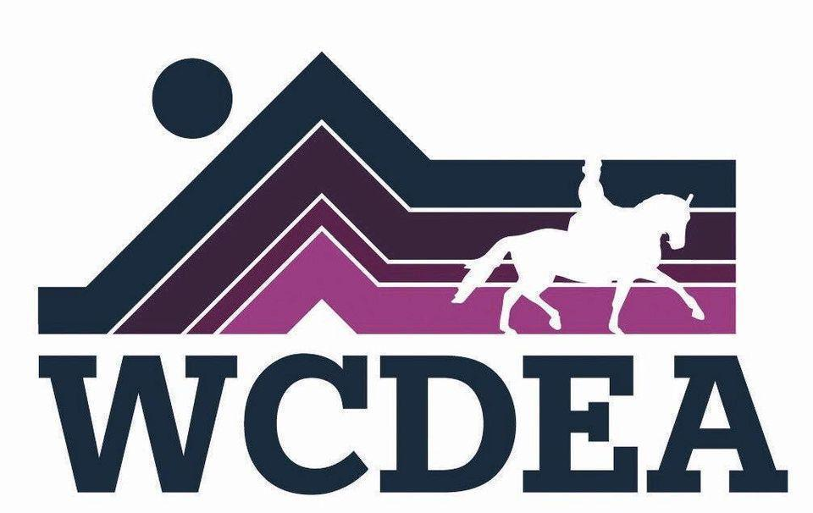

Whatcom County Dressage and Eventing Association
www.wcdea.org
August 2025 Newsletter

July 17, 2025
The July meeting this year was a well attended potluck, in my yard. Delightful to have good friends, good food and great horsey talk. Several new faces came and were welcomed into the WCDEA family.
Folks seemed to appreciate the central location, though there was some nostalgia about being at Sunset Park and having mounted games. Egg and spoon, ride a buck and musical chairs on horseback was as much fun to watch as to be riding.
What a lovely group of folks surround WCDEA.
Carol Landt

Board Musings
This spring and summer the club has put on some fun events! We're hoping to round out the year with a fall schooling show or clinic (costumes VERY welcome!), but we need someone to take the helm to make it happen. If you're interested in helping to make an event happen, please come to the August meeting on 8/21, at Round Table so we can help you to start planning.
~Michelle Becker
Announcements:
WCDEA meeting August 21, 6:30 - 8 at Round table Pizza !

Old business :
Treasurer Report:
No reports were given at picnic
New business: We still need a chairman for the fall 🎃 show if we are to have one. Please let Michelle know asap if you are interested mbecker704@gmail.com

July 12/13, 2025
WCDEA/ FOSF Jointly sponsored Working Equitation Weekend
On Sunday, we held a Working Equitation and Dressage Schooling Show. There were ten participants in the Working Equitation Show and three tests ridden in the Dressage Schooling Show. We offered a speed round section for the WE show for levels above Introductory. That was set up in the sand arena after the dressage court was taken down. It was a bit more work and required more obstacles but was very interesting to watch and the participants seemed to enjoy it very much. We made a net profit of $620 which was split equally between WCDEA and FOSF.

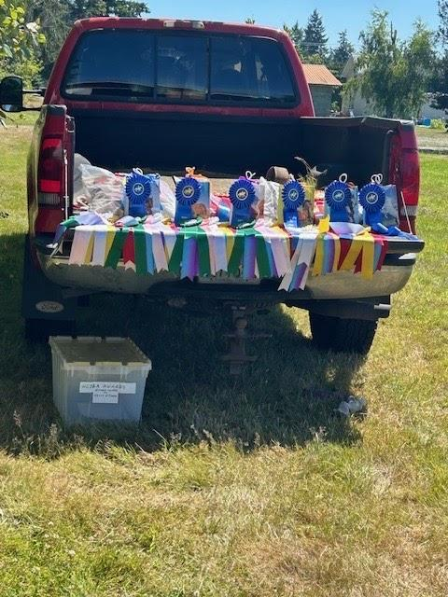
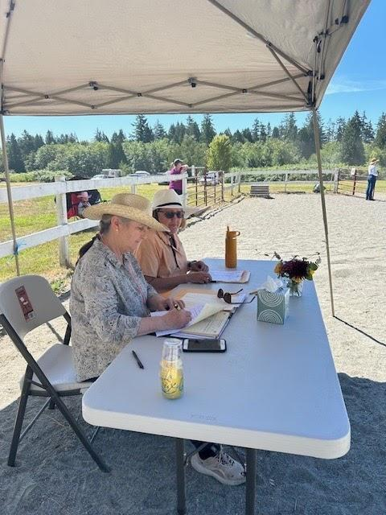

WCDEA/ FOSF Jointly sponsored Working Equitation Weekend

On Saturday we had a Working Equitation clinic with Kim Roe. There were eleven participants in four separate groups. The weather was spectacular and everyone had a wonderful time with Deirdra Dongs lovely obstacles and Sunset Farm Parks water complex and bank jump.

On Sunday, we held a Working Equitation and Dressage Schooling Show. There were ten participants in the Working Equitation Show and three tests ridden in the Dressage Schooling Show. We offered a speed round section for the WE show for levels above Introductory. That was set up in the sand arena after the dressage court was taken down. It was a bit more work and required more obstacles but was very interesting to watch and the participants seemed to enjoy it very much.

We made a net profit of $620 which was split equally between WCDEA and FOSF.
Show results:
High Score Awards:
Best Dressage Score - Jenny Styer
Best Ease of Handling - Sharlet Jones
WE - Intro
1. Jenny Styer
2. Josephine Hegeberg
3. Elka Karl
4. Nadia Carrim
5. Joanna Ford
6. Candace Fritzle

WE - Novice A
- Johanna Rochester

WE - Novice B
- Kathy Adams
WE - Intermediate A
- Sharlet Jones
- Deirdra Dong
Dressage Only (TOC)
- Jenny Styer
- Michele Bennett

Respectfully submitted by clinic/ show co-chairs,
Robbie Harris & Viki Schimke
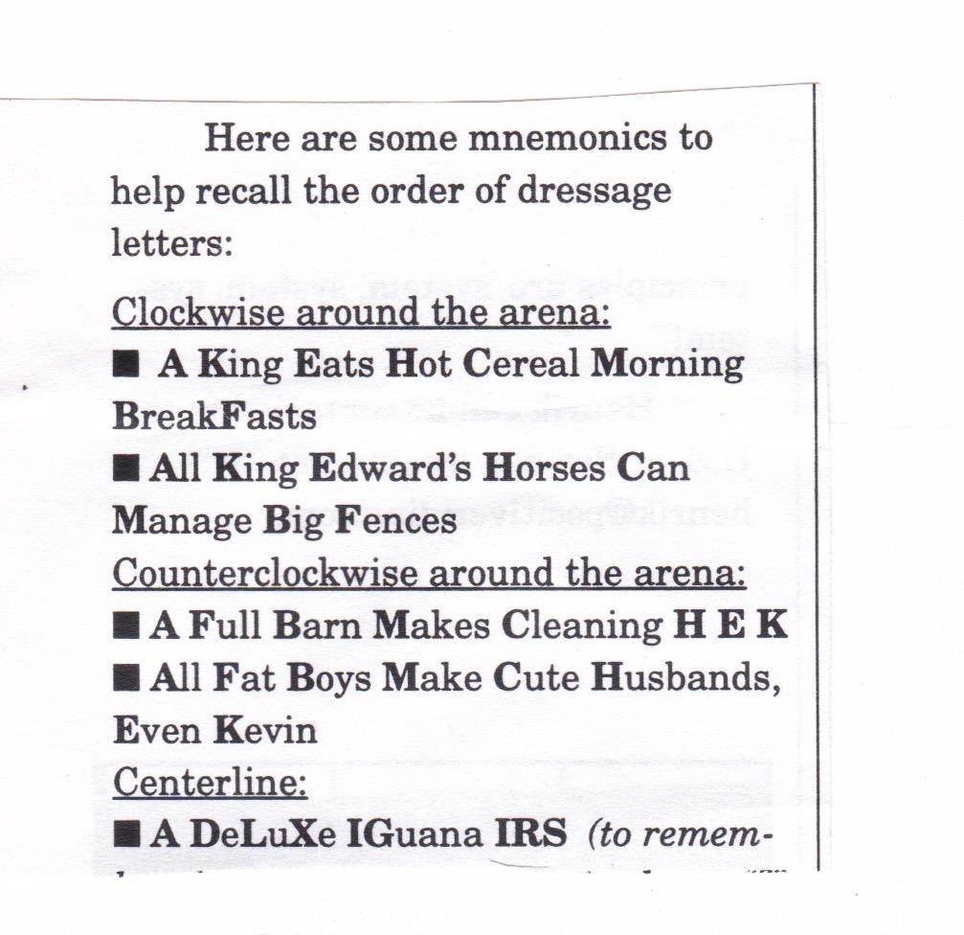
https://www.wcdea.org/
The website is kept up to date by webmistress Jo Rochester. (If organizers get info to Jo, it's on the website.) Thank you, Jo!

