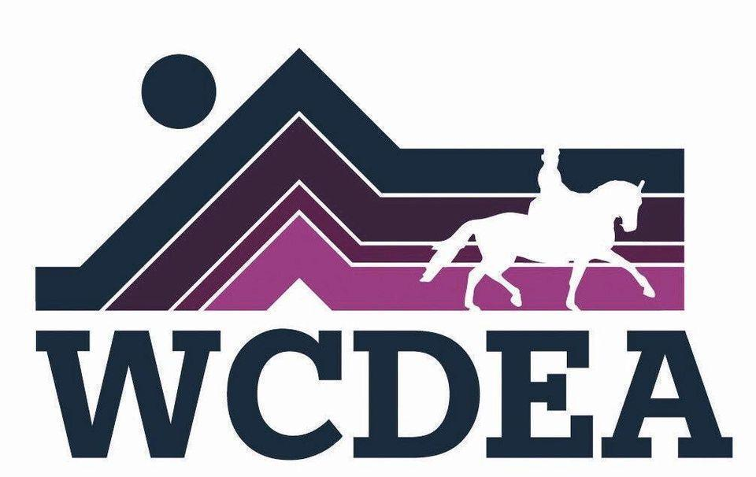

Whatcom County Dressage and Eventing Association
www.wcdea.org
September 2025 Newsletter

Board Musings
Two awesome club members are working on organizing a fall show, with a probable date of October 5th. Keep an eye on the website and Facebook page for more info. And, come to the meeting at Round Table on Sept 18th to learn more, and to see how you can volunteer to help to make this show happen!
It's not too early to start thinking about the annual holiday party. We'll need to choose a date, and a place to gather.

~Michelle

Announcements:

WCDEA meeting September 18th, 6:30 - 8 at

Round Table Pizza !

Old business :
Treasurer Report:
Checking: $2591.01
savings: $2,118.80
Pay Pal: $ 4,909.81
No minutes were taken at the July potluck meeting needing approval.

New business: We would like to hear from members which clinicians they would like the club to host in the future. We did some brain storming about activities and clinicians we would like to have next year. If you have any thoughts or ideas please share with Michelle Becker, club vice president.
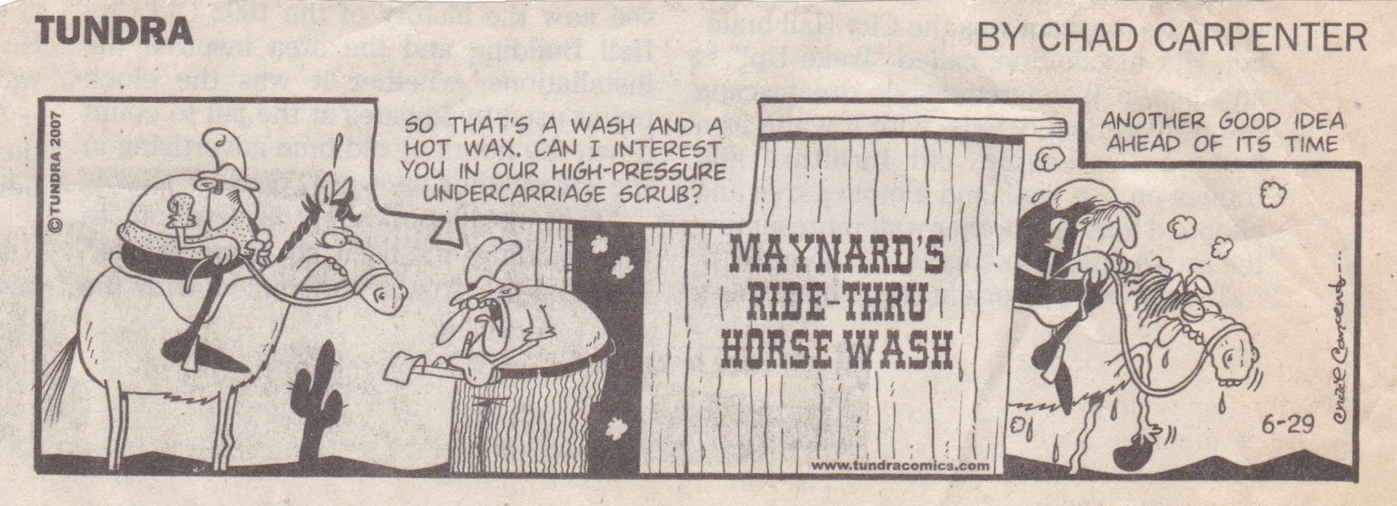
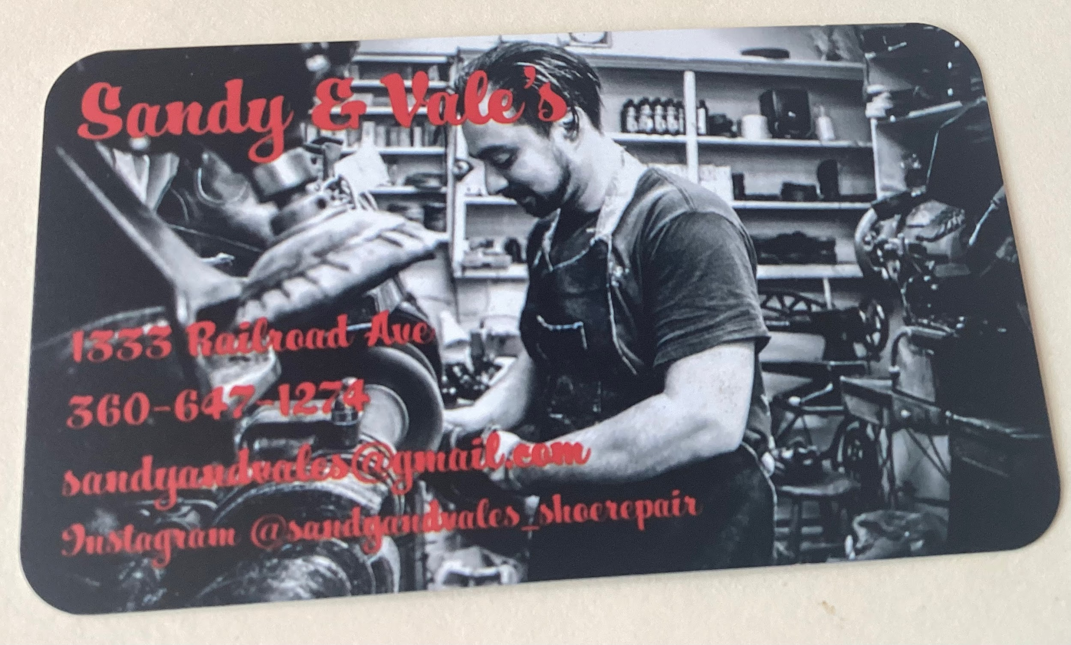
Repairs leather goods like bridles and halters ( its next to the Bagelry and Mallards)

https://www.wcdea.org/
The website is kept up to date by webmistress Jo Rochester.

