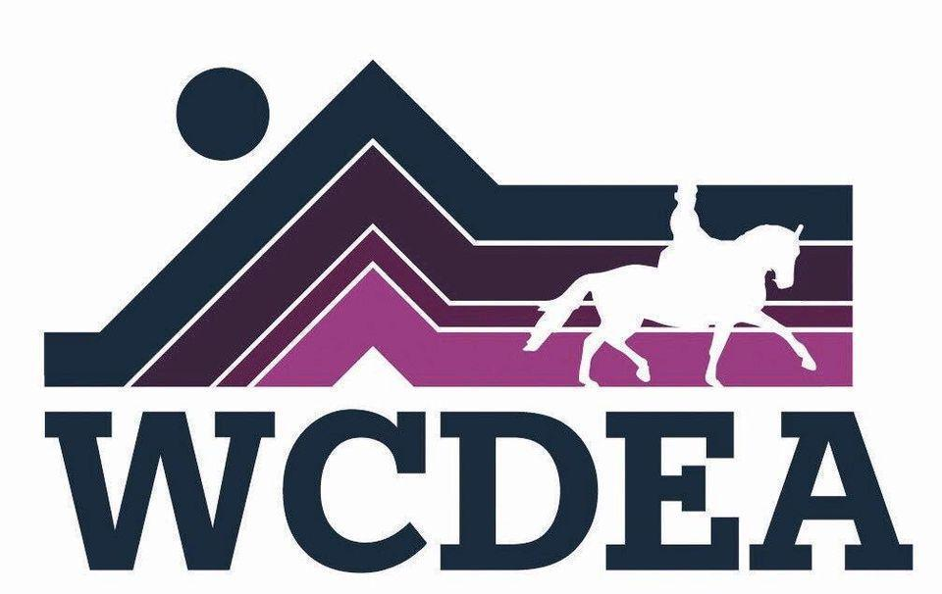

Whatcom County Dressage and Eventing Association
www.wcdea.org
October 2025 Newsletter

Announcements:

WCDEA meeting October 16th, 6:30 - 8 at

Round Table Pizza !


Please join us for the 2025 HalloWEen Dressage & Working Schooling Show on Sunday, October 5th 2025 at beautiful Misty River Ranch!
Still need to get your entry in? Entries close at the end of day on Tuesday, September 30th (some exceptions allowed on a case by case basis if the show isn’t full). The entry form is online at https://wcdea.org/calendar.
We love our volunteers! Please sign up to volunteer for the show! We can train you for any position, no experience necessary! Volunteer sign-up is here: https://volunteersignup.org/8CX9E
Plus, we have a photographer for the show! Email equestrian photographer Emily Vander Haak at strikingchestnutstudio@gmail.com ahead of time to get your rides photographed. She’ll also plan to shoot as many rides as possible for a group album, with photos available for purchase post-show. See some of Emily’s beautiful work here.
All the important details for the show are below:
When: Sunday, October 5th, 2025
Where: Misty River Ranch, 5690 N Fork Rd, Deming, WA
What: Working Equitation tests Intro to Intermediate B (including speed round!), dressage test of choice, Ease of Handling (obstacle) only, and a costume contest!
Who: Anyone interested in working equitation or dressage! Western or English tack, all breeds, all experience levels
Why: Usher in the autumn season with equestrian friends while earning ribbons and prizes.

If you have any questions, please contact the show organizers, Josephine Hegeberg jhegeberg@gmail.com or Elka Karl elkanikkole@gmail.com
And, the next WCDEA Meeting will be on October 16that Round Table Pizza. Come help decide when and where the holiday party will be!
~Michelle

Treasurer Report:
Checking: $2591.01
Savings: $2,118.97
Pay Pal: $ 5,044.12

New business: We would like to hear from members which clinicians they would like the club to host in the future. We did some brain storming about activities and clinicians we would like to have next year. If you have any thoughts or ideas please share with Michelle Becker, club vice president.

https://www.wcdea.org/
The website is kept up to date by webmistress Jo Rochester.

